What to do today
IMPORTANT Parent or Carer – Read this page with your child and check that you are happy with what they have to do and any weblinks or use of internet.

1. Research vocabulary from a poem
- Read or listen to The Highwayman. You could use the PowerPoint or you could use this reading:
https://www.youtube.com/watch?v=99UH0JB7m5A
- Choose some words from Vocabulary List. Can you find out what they could mean? What is their meaning in the poem?

2. Revise and practise adverbials
- Use the Revision Card to remind yourself about adverbials.
- Complete Adverbials Practice.

3. Write a Character Study
- Choose one of the characters that you made notes about yesterday.
- Write about this character. Explain what we learn about them in the poem and imagine what might have happened to them before the poem and what will happen to them afterwards.
- Include adverbials in your writing.

Well done! Share your Character Study with a grown-up. Show them the adverbials that you have used in your writing.

Try the Fun-Time Extra
- Can you make up a play that would tell the story of the Highwayman?
You could act out a scene, or write a script, or make a filmed version with toys.

The Highwayman
By Alfred Noyes

The wind was a torrent of darkness among the gusty trees,
The moon was a ghostly galleon tossed upon cloudy seas,
The road was a ribbon of moonlight, over the purple moor,
And the highwayman came riding –
Riding – riding –
The highwayman came riding, up to the old inn-door.

II
He'd a French cocked-hat on his forehead, a bunch of lace at his chin,
A coat of the claret velvet, and breeches of brown doe-skin;
They fitted with never a wrinkle: his boots were up to the thigh!
And he rode with a jewelled twinkle,
His pistol butts a-twinkle,
His rapier hilt a-twinkle, under the jewelled sky.

III
Over the cobbles he clattered and clashed in the dark inn-yard,
He tapped with his whip on the shutters, but all was locked and barred;
He whistled a tune to the window, and who should be waiting there
But the landlord's black-eyed daughter,
Bess, the landlord's daughter,
Plaiting a dark red love-knot into her long black hair.

IV
And dark in the old inn-yard a stable-wicket creaked
Where Tim the ostler listened; his face was white and peaked;
His eyes were hollows of madness, his hair like mouldy hay,
But he loved the landlord's daughter,
The landlord's red-lipped daughter,
Dumb as a dog he listened, and he heard the robber say –

V
‘One kiss, my bonny sweetheart, I'm after a prize to-night,
But I shall be back with the yellow gold before the morning light;
Yet, if they press me sharply, and harry me through the day,
Then look for me by moonlight,
Watch for me by moonlight,
I'll come to thee by moonlight, though hell should bar the way.’

VI
He rose upright in the stirrups; he scarce could reach her hand,
But she loosened her hair i' the casement! His face burnt like a brand
As the black cascade of perfume came tumbling over his breast;
And he kissed its waves in the moonlight,
(Oh, sweet black waves in the moonlight!)
Then he tugged at his rein in the moonlight, and galloped away to the West.

VII
He did not come in the dawning; he did not come at noon;
And out o' the tawny sunset, before the rise o' the moon,
When the road was a gipsy's ribbon, looping the purple moor,
A red-coat troop came marching-
Marching-marching-
King George's men came marching, up to the old inn-door.

VIII
They said no word to the landlord, they drank his ale instead,
But they gagged his daughter, and bound her, to the foot of her narrow bed;
Two of them knelt at her casement, with muskets at their side!
There was death at every window;
And hell at one dark window;
For Bess could see, through the casement, the road that he would ride.

IX
They had tied her up to attention, with many a sniggering jest;
They bound a musket beside her, with the muzzle beneath her breast!
‘Now, keep good watch!’ and they kissed her.
She heard the dead man say-
Look for me by moonlight;
Watch for me by moonlight;
I'll come to thee by moonlight, though hell should bar the way!

X
She twisted her hands behind her; but all the knots held good!
She writhed her hands till her fingers were wet with sweat or blood!
They stretched and strained in the darkness, and the hours crawled by like years,
Till, now, on the stroke of midnight,
Cold, on the stroke of midnight,
The tip of one finger touched it! The trigger at least was hers!

XI
The tip of one finger touched it; she strove no more for the rest!
Up, she stood up to attention, with the muzzle beneath her breast,
She would not risk their hearing; she would not strive again;
For the road lay bare in the moonlight;
Blank and bare in the moonlight;
And the blood of her veins in the moonlight throbbed to her love's refrain.

XII
Tlot-tlot; tlot-tlot! Had they heard it? The horse-hoofs ringing clear;
Tlot-tlot; tlot-tlot, in the distance? Were they deaf that they did not hear?
Down the ribbon of moonlight, over the brow of the hill,
The highwayman came riding,
Riding, riding!
The red-coats looked to their priming! She stood up straight and still.

XIII
Tlot-tlot, in the frosty silence! Tlot-tlot, in the echoing night!
Nearer he came and nearer! Her face was like a light!
Her eyes grew wide for a moment; she drew one last deep breath,
Then her finger moved in the moonlight,
Her musket shattered the moonlight,
Shattered her breast in the moonlight and warned him - with her death.

XIX
He turned; he spurred to the West; he did not know who stood
Bowed, with her head o'er the musket, drenched with her own red blood!
Not till the dawn he heard it, his face grew grey to hear
How Bess, the landlord's daughter,
The landlord's black-eyed daughter,
Had watched for her love in the moonlight, and died in the darkness there.

XX
Back, he spurred like a madman, shouting a curse to the sky,
With the white road smoking behind him and his rapier brandished high!
Blood-red were his spurs i' the golden noon; wine-red was his velvet coat,
When they shot him down on the highway,
Down like a dog on the highway,
And he lay in his blood on the highway, with the bunch of lace at his throat.

XXI
And still of a winter's night, they say, when the wind is in the trees,
When the moon is a ghostly galleon tossed upon cloudy seas,
When the road is a ribbon of moonlight over the purple moor,
A highwayman comes riding –
Riding – riding –
A highwayman comes riding, up to the old inn-door.

XXII
Over the cobbles he clatters and clangs in the dark inn-yard,
And he taps with his whip on the shutters, but all is locked and barred;
He whistles a tune to the window, and who should be waiting there
But the landlord's black-eyed daughter,
Bess, the landlord's daughter,
Plaiting a dark red love-knot into her long black hair.

by Alfred Noyes

Note the use of tlot, tlot (instead of clip, clop as used in the Animated Tale) in the original text

Vocabulary List

pistol galleon

brandished musket

cascade stirrups

breeches rapier

cobbles bonny

shutters cocked-hat

ostler harry

casement red-coat

muzzle priming

jest

Revision Card - Adverbials
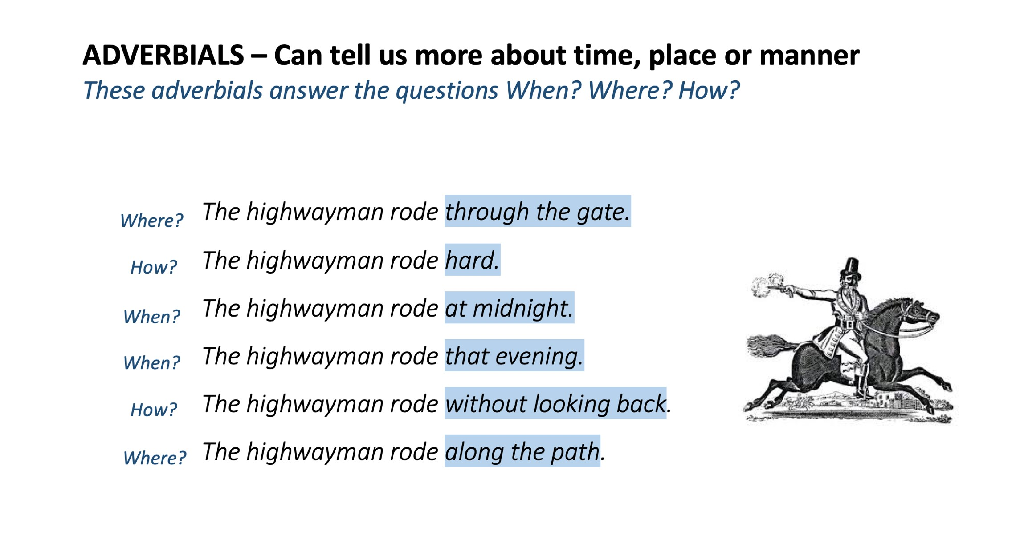

Adverbials Practice

Find the adverbials and show whether they answer where, how or when.

Over the cobbles he clatters and clangs in the dark inn-yard.
He taps with his whip on the shutters.
They shot him down like a dog on the highway.
Her eyes grew wide for a moment.
He spurred to the west.
I shall be back with the yellow gold before the morning light.
His face burnt like a brand.
(brand = piece of metal which has been heated in fire)
The hours crawled by like years.
The highwayman came riding up to the old inn door.
He rode with a jewelled twinkle under a jewelled sky.
Not till the dawn did he hear it.

Character Study
Write about your character here. What do we know about them? What do you imagine happens to them before and after the poem? Use adverbials in your writing.

Adverbials Practice – Answers

WHERE? HOW? WHEN?

Over the cobbles he clatters and clangs in the dark inn-yard.
He taps with his whip on the shutters.
They shot him down like a dog on the highway.
Her eyes grew wide for a moment.
He spurred to the west.
I shall be back with the yellow gold before the morning light.
His face burnt like a brand.
(brand = burning piece of wood)
The hours crawled by like years.
The highwayman came riding up to the old inn door.
He rode with a jewelled twinkle under a jewelled sky.
Not till the dawn did he hear it.

Vocabulary List - answers

pistol - small fire arm designed to be held in one hand

galleon - a sailing ship in use between 15th and 18th centuries. First a warship and then used for trade.

brandished – waved threateningly or flourished

musket – a light gun with a long barrel, usually fired from the shoulder

cascade – a wave of perfume

stirrups – a pair of loops with a metal bar attached to the horse’s saddle to hold the riders’ foot on each side

breeches – short trousers fastened just below the knee

rapier – a thin, light, sharp=pointed sword

cobbles – small round stones covering the road surface. Used from Roman times and before.
bonny – attractive or beautiful

shutters – a pair of hinged wooden panels fixed outside the window

cocked-hat - a brimless triangular hat pointed at the front, back, and top

ostler – a man employed to look after the horses of people staying at the inn

harry – chase and harass

casement – a window or part of a window that opens like a door

red-coat – a British soldier

muzzle - the open end of the barrel of a gun

priming - gunpowder placed in the pan of a firearm to ignite a charge

jest – joke or amusing saying

