What to do today
IMPORTANT Parent or Carer – Read this page with your child and check that you are happy with what they have to do and any weblinks or use of internet.

1. Read a poem
- Read the poem: Mother to Son. What message is there in the poem?
- Listen to the poem being performed. Does it sound like you expected?
https://www.youtube.com/watch?v=NX9tHuI7zVo

2. Answer questions about poems
- Read Keep on Keepin On and answer the Questions.
- Challenge yourself to read Don’t Quit and to answer its Questions.

Well done! Share your answers with a grown-up. Look at the poems together and explain your answers to them.

3. Choose some quotations
- Go through the three poems and choose your favourite lines. Underline these.
- Choose one of your favourite lines and make it into a poster to inspire you or somebody in your family.

Try the Fun-Time Extras
- Find out more about Langston Hughes. What can you learn about him or his poems?
- Send an inspirational line of poetry or a copy of a whole poem to somebody that you haven’t seen recently. Write to them to explain why you have chosen it for them.

Mother to Son

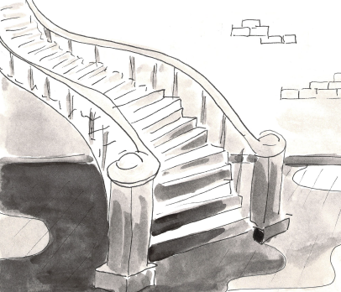
Well, son, I’ll tell you:
Life for me ain’t been no crystal stair.
It’s had tacks in it,
And splinters,
And boards torn up,
And places with no carpet on the floor—
Bare.
But all the time
I’se been a-climbin’ on,
And reachin’ landin’s,
And turnin’ corners,
And sometimes goin’ in the dark
Where there ain’t been no light.
So boy, don’t you turn back.
Don’t you set down on the steps
’Cause you finds it’s kinder hard.
Don’t you fall now—
For I’se still goin’, honey,
I’se still climbin’,
And life for me ain’t been no crystal stair.
Langston Hughes,
The Collected Poems of Langston Hughes,
Vintage, 1995

Keep On Keeping On

We’ve all had times when the going gets tough
The smooth ride suddenly feels bumpy and rough
The good times are gone, it’s all rather gruff
You let out a sigh and exclaim– “I’ve had enough”

We are all entitled at times, to gripe and to moan
What’s happened to my life, you say with a groan?
My backpack seems weighed down by a very big stone
How do I move away from this miserable zone?

When a curved ball hits you, through a trick or a con
Remember the good days, when the sun always shone
Go forward with the belief that you already have won
The best advice I can give is to keep on–keeping on

Michael Sage

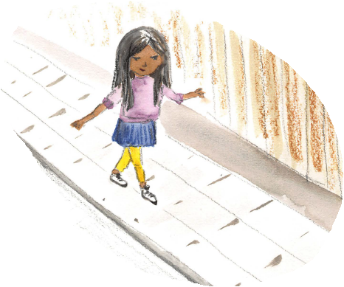

Questions about Keep On Keeping On

- What does gruff (line 3) mean?

- There is no sentence-end punctuation at the finish of the line in verse 1 which closes, …I’ve had enough. Which sentence-end punctuation do you think might work best here? Why do you think that?

- Quote the line in the poem that suggests that, from time to time, everybody has the right to moan about things that are frustrating them.

- In verse 2 the poet talks of a backpack weighed down by a very big stone. What do you think the poet means by this?

- Can you give an example of the kind of thing that the poet might be suggesting is a very big stone?

- Would you say the overall mood of the poem is optimistic or pessimistic? Why do you think that?

- In your own words, say what you think Michael Sage’s main message in the poem is.

Don’t Quit

When things go wrong, as they sometimes will,
When the road you're trudging seems all uphill,
When the funds are low and debts are high,
And you want to smile but have to sigh,
When care is pressing you down a bit,
Rest, if you must, but don't you quit.

Life is queer with its twists and turns,
As everyone of us sometimes learns,
And many a failure turns about,
When he might have won if he'd stuck it out,
Don't give up though the pace seems slow,
You might succeed with another blow.

Often the struggler has given up,
When he might have captured the victor's cup.
And he learned too late, when the night slipped down,
How close he was to the golden crown,

Success is failure turned inside out,
The silver tint of clouds of doubt,
And you never can tell how close you are,
It may be near when it seems afar,
So stick to the fight when you're hardest hit,
It's when things seem worst that you mustn't quit.
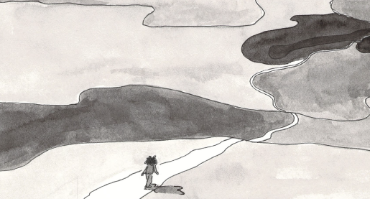

Anon,
http://www.all-creatures.org/poetry/dontquit.html
Questions about Don’t Quit

- The poet uses the verb trudging on line 2: can you suggest a synonym for this verb?

- Quote the two lines in verse 2 which suggest that, when faced with a problem, you should never give up just because nothing seems to be happening, as you may find that with your very next try, things completely change.

- Judging from the poem, which of these words best sums up the way the poet thinks we should be in the face of problems–reckless, undaunted or despondent? What in the poem tells you this?

- Explain in your own words what the poet means by the lines: Often the struggler has given up,
When he might have captured the victor's cup.

5. Imagine a person or a group of people to whom this poem
would be really good advice and say why you think it might help them.

6. No-one is sure who wrote Don’t Quit. What kind of person do you think they would have been and why?

