What to do today
IMPORTANT Parent or Carer – Read this page with your child and check that you are happy with what they have to do and any weblinks or use of internet.

1. Re-read and watch a poem
- Watch Wilf Merttens perform his poem:
https://www.youtube.com/watch?v=GGXCSulVamo
- What does Wilf Merttens do when he performs his poem? Make a note of three things that you spot.
- If you haven’t read the poem, re-read it.

2. Revise modal verbs
- Use the PowerPoint on modal verbs and listen to the teaching. If this is not possible, remind yourself using the Revision Card.
- Go through the poem: What do you want to be? and see if you can spot and highlight any modal verbs. There are only a few examples so look carefully.

3. Now for some writing
- Write Sets of Three. Write about your future using different modal verbs to show how certain you are.

Well done. Share your sentences with a grown-up and explain the modal verbs that you have chosen to use.

Try the Fun-Time Extras
- Practise performing What do you want to be? Try using some of the techniques that you saw Wilf Merttens use. Can you start to learn any of the poem off by heart?
- Share your performance with somebody else.
What do you want to be?

What do you want to be?
What do you want to be?
What do you want to be?

Hey listen kid, you don’t have to tell me–
I’m just here to read some poetry.
You can leave now if you want.
You’re completely free, you see.
But, before you go, let me tell you
I’m not here to tell you about birds and bees
and trees
and bananas and farmers and poetry things.
This poem is a question,
and I’m asking what you dream and feel and things.

You see, maybe you want to be famous.
Maybe you want to be an astronaut and explore Uranus.
Maybe you want to be the craziest stunt lady Hollywood’s ever seen.
Maybe you want to buy some flashy mansion
and spend all your time keeping it clean.
Maybe you’re a dancer and Bollywood’s more your scene.
Maybe you’re a natural,
Maybe you’re going to have work hard at it.
Maybe you’re a punk singer and you want to smash…it…up.
Maybe you like nice stuff.
Maybe to get it you’re going to act all tough.
Maybe you’re going to be sweet.
Maybe you’re going to meet and greet.
Maybe you just want to help people.
Or maybe you want to be a success, like prove that you’re the best.
Maybe you want to be a celebrity, or an important politician,
shake the hands of the mayor.
Then again, maybe you just don’t care.
Maybe you’re in it for the money.
Now that’s a sweet honey.
People don’t find anything funny when they’re racing to be rich.
Maybe you want to be surrounded by iPhones and quick fixes,
Maybe your heart tremors and twitches round diamond rings and bling.
Maybe you want to see all the precious things that eBay can bring,
Or wear so many jewels you look like a King.
Maybe you just want to sing in the shower
and that’s what makes you feel free.
Maybe all you need is the moon and a tree to feel happy.
Maybe you’re a natural.
Maybe you’re a doctor, a tinker, a tailor, an architect of bad behaviour.
You could be a soldier or a spy.
You could be the kind of guy who wonders why
the world is just as it is
Or how the plane can stay in the sky.
Maybe you’re an expert at stopping a baby crying.
Maybe you’ll be found frying a rich man’s breakfast
in a gourmet restaurant.
Maybe you’re a killer chef or an amazing painter.
You don’t have to know now;
you can find out later what it is you really want to be.
Because maybe you just want to see the world.
Maybe you want to travel around and live out of a backpack.
Maybe you want to be a goth, wearing nothing but black
‘cos maybe being blue just ain’t you.
Maybe you just have to find out what’s true and what’s a lie in the newspaper.
Maybe you’d make a kiss-ass journalist.
Then again maybe all that writing would turn you mentalist.
Maybe you want to make your own zombie movies,
spray ketchup all over your mate’s face for fake blood,
Maybe you want to be a dirt biker all covered in mud,
or a rescue woman saving people in a flood.
Maybe you want to be a boxer, landing punches with a thud.
Maybe you want to do very little,
live life quietly up a mountain someplace,
stay up all night staring into space.
Maybe you want to raise a family.
Maybe you want to devote your life to a god.
Maybe you want to live in a caravan on the sea, serving cod and chips.
Maybe you’ll be eternally swell if you can just kiss a sweet pair of lips

Whatever your dream, I’m just here to remind you that you can be whatever you want to be and you can have anything, you see.
Now if you’re like me you’re going to want it all for free.
But like me and like lots of other people like me,
in the end you’re going to see
that if you want to be what you want to be
then you are going to have believe
and work real hard.
Unless you just want to be a nobody, which is real easy.
But don’t worry, ‘cos this crazy game is not a race,
and it’s not up to me or school or TV to tell you your place.
We don’t know your dream, or even what you really mean
when you say what you want to be.
It’s up to you.
You’ve got to decide for yourself you see.
Now, tell me - what do you want to be?
Wilf Merttens
Revision Card – Modal Verbs

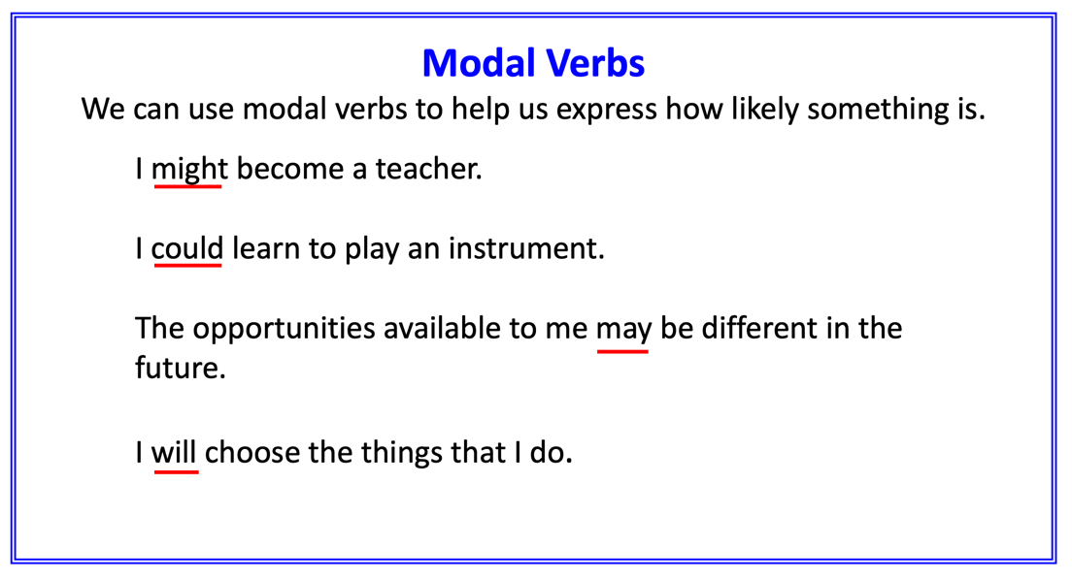 | 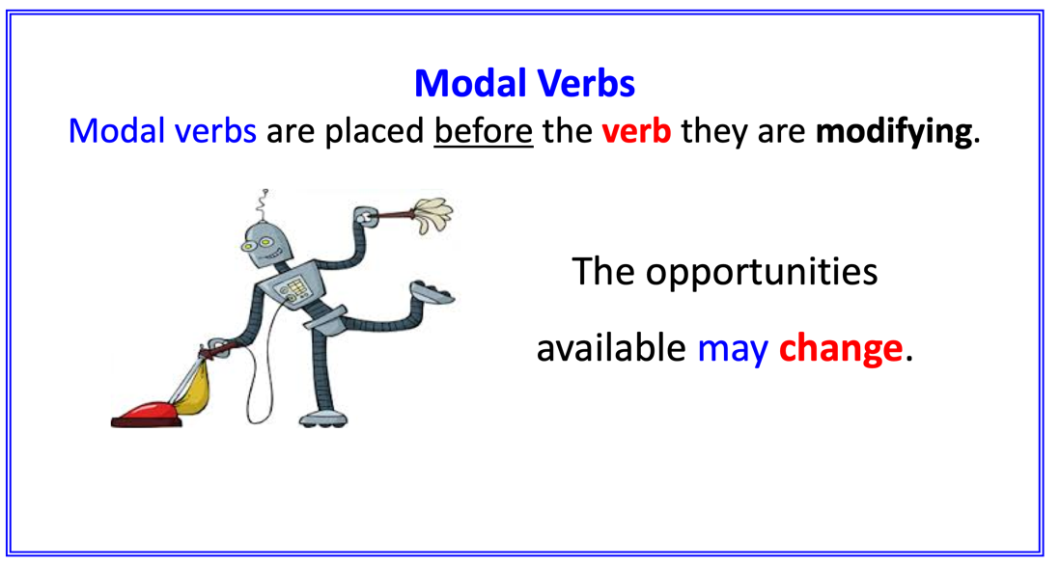
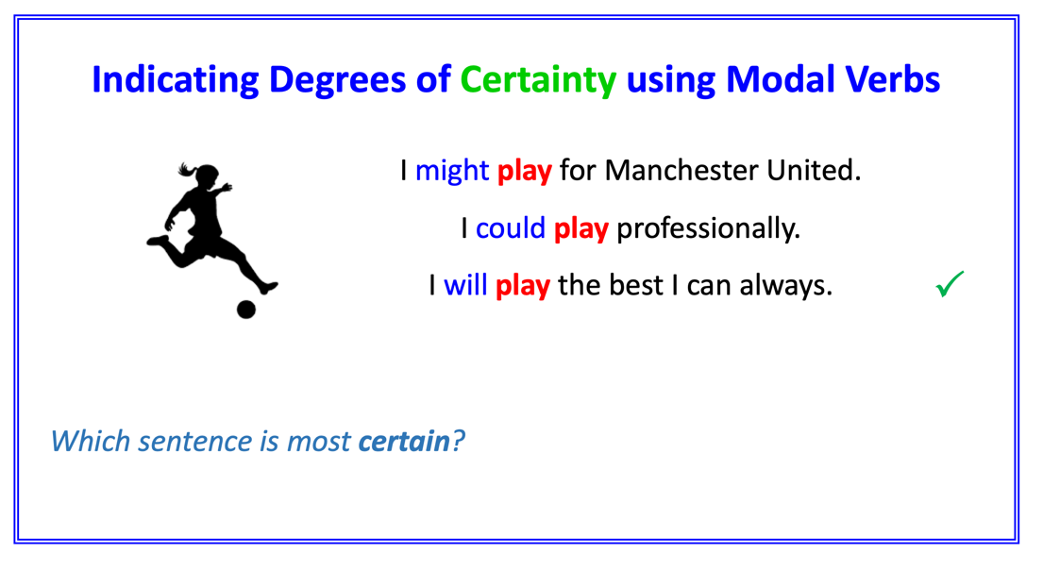 | 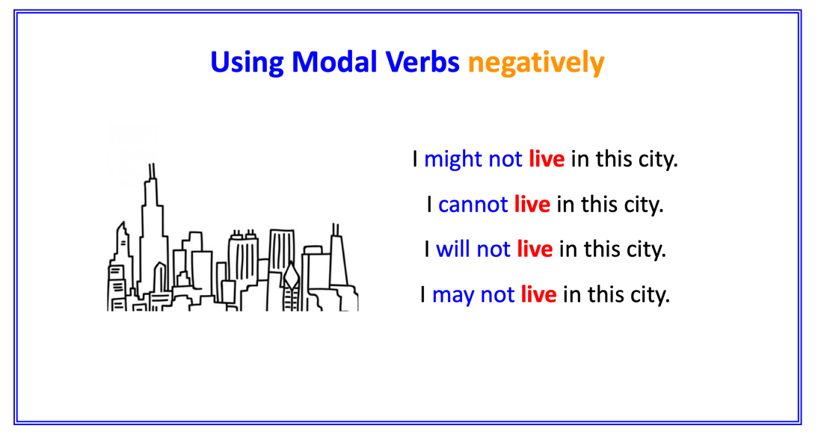

Sets of Three
Write sentences about your future using different modal verbs.

 | Possible | Possible | Certain
What job you will do | e.g. I might play for Southampton. | e.g. I could play professionally. | e.g. I will always make time for football.
What hobby you will have
The place you will live
Your greatest achievement
The kind of person you will be

What do you want to be? – Modal Verbs
Answers

What do you want to be?
What do you want to be?
What do you want to be?

Hey listen kid, you don’t have to tell me–
I’m just here to read some poetry.
You can leave now if you want.
You’re completely free, you see.
But, before you go, let me tell you
I’m not here to tell you about birds and bees
and trees
and bananas and farmers and poetry things.
This poem is a question,
and I’m asking what you dream and feel and things.

You see, maybe you want to be famous.
Maybe you want to be an astronaut and explore Uranus.
Maybe you want to be the craziest stunt lady Hollywood’s ever seen.
Maybe you want to buy some flashy mansion
and spend all your time keeping it clean.
Maybe you’re a dancer and Bollywood’s more your scene.
Maybe you’re a natural,
Maybe you’re going to have work hard at it.
Maybe you’re a punk singer and you want to smash…it…up.
Maybe you like nice stuff.
Maybe to get it you’re going to act all tough.
Maybe you’re going to be sweet.
Maybe you’re going to meet and greet.
Maybe you just want to help people.
Or maybe you want to be a success, like prove that you’re the best.
Maybe you want to be a celebrity, or an important politician,
shake the hands of the mayor.
Then again, maybe you just don’t care.
Maybe you’re in it for the money.
Now that’s a sweet honey.
People don’t find anything funny when they’re racing to be rich.
Maybe you want to be surrounded by iPhones and quick fixes,
Maybe your heart tremors and twitches round diamond rings and bling.
Maybe you want to see all the precious things that eBay can bring,
Or wear so many jewels you look like a King.
Maybe you just want to sing in the shower
and that’s what makes you feel free.
Maybe all you need is the moon and a tree to feel happy.
Maybe you’re a natural.
Maybe you’re a doctor, a tinker, a tailor, an architect of bad behaviour.
You could be a soldier or a spy.
You could be the kind of guy who wonders why
the world is just as it is
Or how the plane can stay in the sky.
Maybe you’re an expert at stopping a baby crying.
Maybe you’ll be found frying a rich man’s breakfast
in a gourmet restaurant.
Maybe you’re a killer chef or an amazing painter.
You don’t have to know now;
you can find out later what it is you really want to be.
Because maybe you just want to see the world.
Maybe you want to travel around and live out of a backpack.
Maybe you want to be a goth, wearing nothing but black
‘cos maybe being blue just ain’t you.
Maybe you just have to find out what’s true and what’s a lie in the newspaper.
Maybe you’d make a kiss-ass journalist.
This is a shortened form of: Maybe you would make a kiss-ass journalist

Then again maybe all that writing would turn you mentalist.
Maybe you want to make your own zombie movies,
spray ketchup all over your mate’s face for fake blood,
Maybe you want to be a dirt biker all covered in mud,
or a rescue woman saving people in a flood.
Maybe you want to be a boxer, landing punches with a thud.
Maybe you want to do very little,
live life quietly up a mountain someplace,
stay up all night staring into space.
Maybe you want to raise a family.
Maybe you want to devote your life to a god.
Maybe you want to live in a caravan on the sea, serving cod and chips.
Maybe you’ll be eternally swell if you can just kiss a sweet pair of lips
This is a shortened form of ‘Maybe you will be eternally swell…’

Whatever your dream, I’m just here to remind you that you can be whatever you want to be and you can have anything, you see.
Now if you’re like me you’re going to want it all for free.
But like me and like lots of other people like me,
in the end you’re going to see
that if you want to be what you want to be
then you are going to have believe
and work real hard.
Unless you just want to be a nobody, which is real easy.
But don’t worry, ‘cos this crazy game is not a race,
and it’s not up to me or school or TV to tell you your place.
We don’t know your dream, or even what you really mean
when you say what you want to be.
It’s up to you.
You’ve got to decide for yourself you see.
Now, tell me - what do you want to be?
Wilf Merttens

