Indian Musical Instruments

Bollywood here we come!
Name:_________

Our Experiments and Investigations
Children should begin by exploring the characteristics of certain instruments and how they can be modified to alter the sound.
Children explored and investigated the way in which shakers work using tins, dry sand, dried peas and paper clips. Children discussed and described the sounds made by each filling. They also explored other percussion instruments such as drums as well as stringed instruments such as guitars and violins.
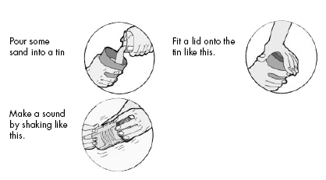
The filler I liked the best was ________________ because___________________________________________________________________________________________
Explain how you changed the pitch of the note from the drum or a stringed instrument? ___________________________________________________________________________________________________________________________________________________________________________________________
My Design Plan
How will the sound be made?

What equipment will I need?

What must I do?
First | Second | Third
Fourth | Fifth | Sixth

This is what my Musical Instrument will look like

After the investigations, children began to design their own musical instrument (which they would later make). Children had to design a musical instrument that worked well but also looked good; therefore they had to spend time thinking about how to decorate it. Children listed the equipment they would need to create their musical instrument and attempted to sequence the steps they would take to create their musical instrument. (Level 1 D7, D8/ Level 2 D5).

Making my Musical Instrument

Children created their musical instruments using household items. Their design plans were used as a guide to create their instruments.

Insert image

What I like about my Musical Instrument
____________________________________________________________________________________________________________________________________________

My Performance
Insert image

