Shelters LO: To design a shelter which is fit for purpose

KEY QUESTION: Bear Grylls’ adventures found him having to rest, eat and shelter in rather unwelcoming surroundings. He would have to build a shelter for his own safety that would protect him from heavy rainfall, fierce winds, predatory animals and falling trees. Often, Grylls would find that his shelter would only protect him from one or two of these dangers. Can you create a shelter which would protect Grylls from all four natural dangers?

To start with, you were asked to explore different types of shelters: their properties and functions; and how successful they would be in protecting from wind, rain and weight.
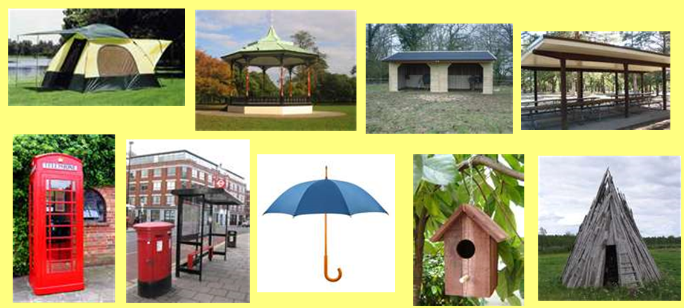
To refresh your memories, some of the types of shelters you looked at might of been:

Before moving on to the next task, look at each picture once more and consider whether any of the shelters’ properties could be useful to Grylls’ challenge.
For example: the tent may not be able to withstand much weight or wind, but the material used is waterproof.

Your task: design your own shelter which would suit the Key Question above.
Use the properties you have considered from existing shelters to influence your design, then label the design explaining your choices.
Your shelter must be:
- Big enough for Bear Grylls to rest inside
- Strong enough to withstand a heavy weight (eg. a falling tree)
- Waterproof
- Windproof
- Secure enough to protect from deadly animals

Next week, you will be asked to add specific properties and functions to your design, so this week just focus on these 5 key features.

