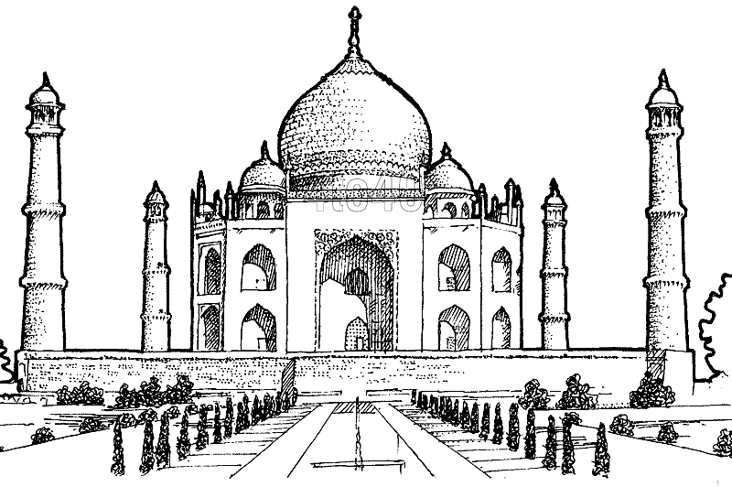

It was built as the final resting place for ……………………………………………, the third wife of Mughal emperor Shah Jahan.

The Taj Mahal was built entirely out of …………………………………………………, which was brought in from all over India and Asia

The Taj Mahal

The Taj Mahal is a famous ……………………………………… in India.

The full height of the Taj Mahal is …………………………………….

The Taj Mahal was built by Emperor

………………………………., which means King of the World, in honour of his dead wife

The Taj Mahal is located in the city of …………………………...

The name Taj Mahal means

…………………………………………………

……………………..

Construction of the Taj Mahal started in ……………………..