A Land of Contrasts
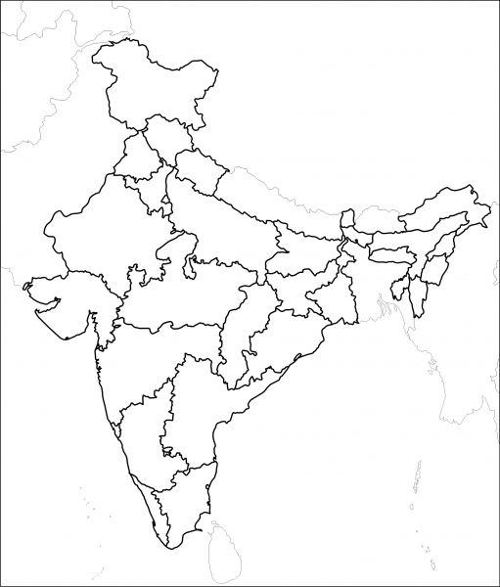

After watching this clip,
- Can you locate the three different regions mentioned on the India Map above?
- Tell me about a local industry and businesses commonly found in that region
- From your research any other interesting information about these areas.

