LO: To add a mechanical device into my design

KEY QUESTION: Bear Grylls’ adventures found him having to rest, eat and shelter in rather unwelcoming surroundings. He would have to build a shelter for his own safety that would protect him from heavy rainfall, fierce winds, predatory animals and falling trees. Often, Grylls would find that his shelter would only protect him from one or two of these dangers. Can you create a shelter which would protect Grylls from all four natural dangers?

Last week, you were asked to design a shelter for Bear Grylls to rest in.
This next stage of your of the task is to add specific properties and functions to your design.
The main property that you will need to include is a lever.
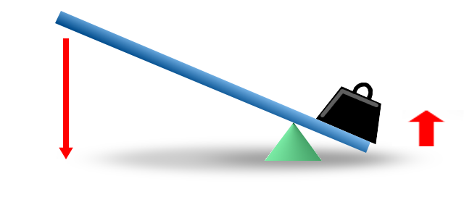
Lever: a rigid bar resting on a pivot, used to move a heavy or firmly fixed load with one end when pressure is applied to the other.

Pivot

There are many ways in which your lever could be included in your design
Here are just two examples:
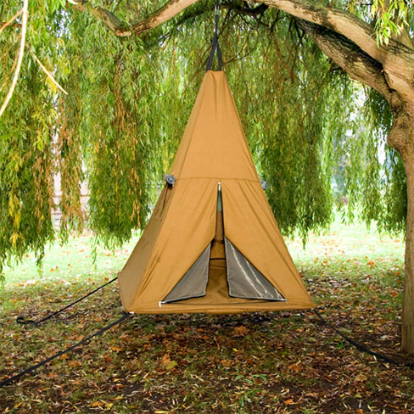
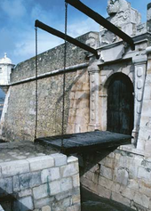
A draw-bridge style lever which creates a secure doorway for Grylls to leave and enter his shelter.

A hoist-style lever which enables the structure to be lifted off the ground (securing the structure further from animals, insects and perhaps flooding!). This same lever style could even be used inside the shelter to protect Grylls’ food or even lift his bed off the ground.

Activity:
On the back of your original design, or on a separate sheet, draw a diagram showing how you will incorporate a lever mechanism into your shelter design.
Think carefully about the materials the lever will be made from, and what will be used as the downward force to control the lever.

Other properties you might want to consider including:
- The overall design of your outer structure: will it be camouflage to confuse deadly animals? OR should it be brightly coloured so Grylls can find the protective shelter easily?
- A doorway: if not included as part of the lever mechanism, how will Grylls leave and enter the shelter?
- Moving the shelter: is it possible to dismantle the shelter and carry elsewhere? If this is a property you want to include, consider the weight of the materials you have chosen, will Grylls be able to carry them easily?

