National Flag:

- orange represents _______ and_______
- white represents truth and ___________
- green represents _______ and prosperity
- the symbol in the centre (Ashoka Chakra) stands for the laws of ____________

The name India comes from _______, which originates from the Old Persian word ________.

Continent: Southern ______________

Capital City: _________________ (but the largest city is Mumbai)

Languages: The main language is ___________ but most people speak English as well

Population: _________________ people (the UK has 0.064 billion or 64 million)

Currency: _____________

Time Zone: The time in India is ________________ hours ahead of GMT (in London).

Religion: The main religion is _________________.

Prime Minister: Narendra _____________ (2014)
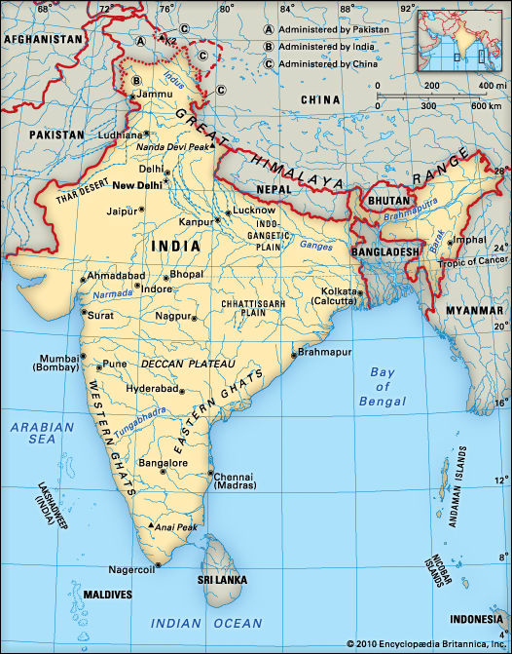
Please find and label New Delhi with *

There are three bodies of water around India – the _____________ Ocean, _____________ Sea and Bay of ______________.

It borders with 7 other countries. They are: Afghanistan, Bangladesh, Bhutan, Burma, C_____, N____________, P______________ and Sri Lanka.

The _________________ Mountains stretch across the top of India. The tallest mountain in the world is part of the Himalayas – Mount Everest.

The main river in India is the ____________, in the northeast of the country.

