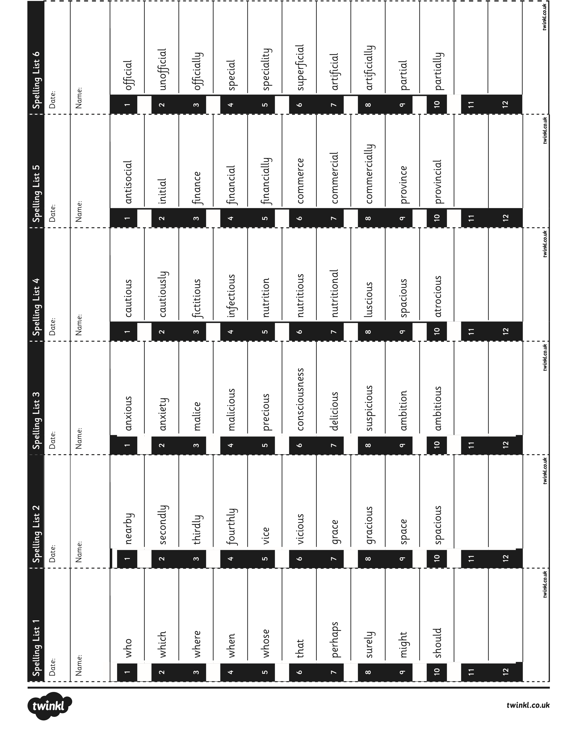**Spelling List** - **Summer Term 1**