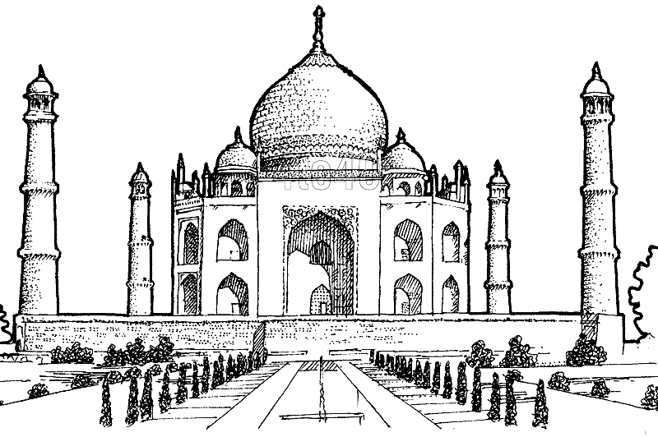

The Taj Mahal was made purely of white marble ! They got the white marble from all over India and Asia

The Taj Mahal was built for the emperor’s third wife!

The Taj Mahal took 21 years to build!

The Taj Mahal

Did you know that after the builders built the Taj Mahal the emperor cut of their hands so they couldn’t build anything more beautiful!